**Selected Problems - Chapter 7**

**2.5** (a)

|  |  |  |  |
| --- | --- | --- | --- |
| Number of Workers | Number of Oil Changes | *mp*l | *ap*l |
| 0 | 0 | — | — |
| 1 | 6 | 6 | 6.00 |
| 2 | 14 | 8 | 7.00 |
| 3 | 26 | 12 | 8.67 |
| 4 | 40 | 14 | 10.00 |
| 5 | 52 | 12 | 10.40 |
| 6 | 58 | 6 | 9.67 |
| 7 | 61 | 3 | 8.71 |
| 8 | 60 | −1 | 7.50 |
| 9 | 48 | −12 | 5.33 |

(b) Between 1 and 4 workers, there are increasing returns to labor. (*MPL* increases as more workers are hired.) From 4 to 7 workers, there are diminishing returns to labor. (*MPL* decreases as more workers are hired, but is still positive.) From 7 to 9 workers, returns to labor are negative because *MPL* is negative.

(c) Marginal product is greater-than-average product for the second, third, fourth, and fifth workers, and average product rises as these two workers are hired.

(d) Marginal product is less-than-average product for the sixth, seventh, eighth, and ninth workers. As each of these workers is hired, the average product of labor declines.

**3.1** (a) Total costs of each technique are as follows:

|  |  |  |  |  |  |
| --- | --- | --- | --- | --- | --- |
|  | Q = 1 | Q = 2 | Q = 3 | Q = 4 | Q = 5 |
| Tech a | $14 | $22 | $35 | $50 | $57 |
| tech b | $9 | $16 | $28 | $39 | $51 |

Technique B is cheaper at all levels of output.

(b)

|  |  |  |
| --- | --- | --- |
| Q | L | K |
| 1 | 3 | 1 |
| 2 | 5 | 2 |
| 3 | 8 | 4 |
| 4 | 12 | 5 |
| 5 | 15 | 7 |

(c)

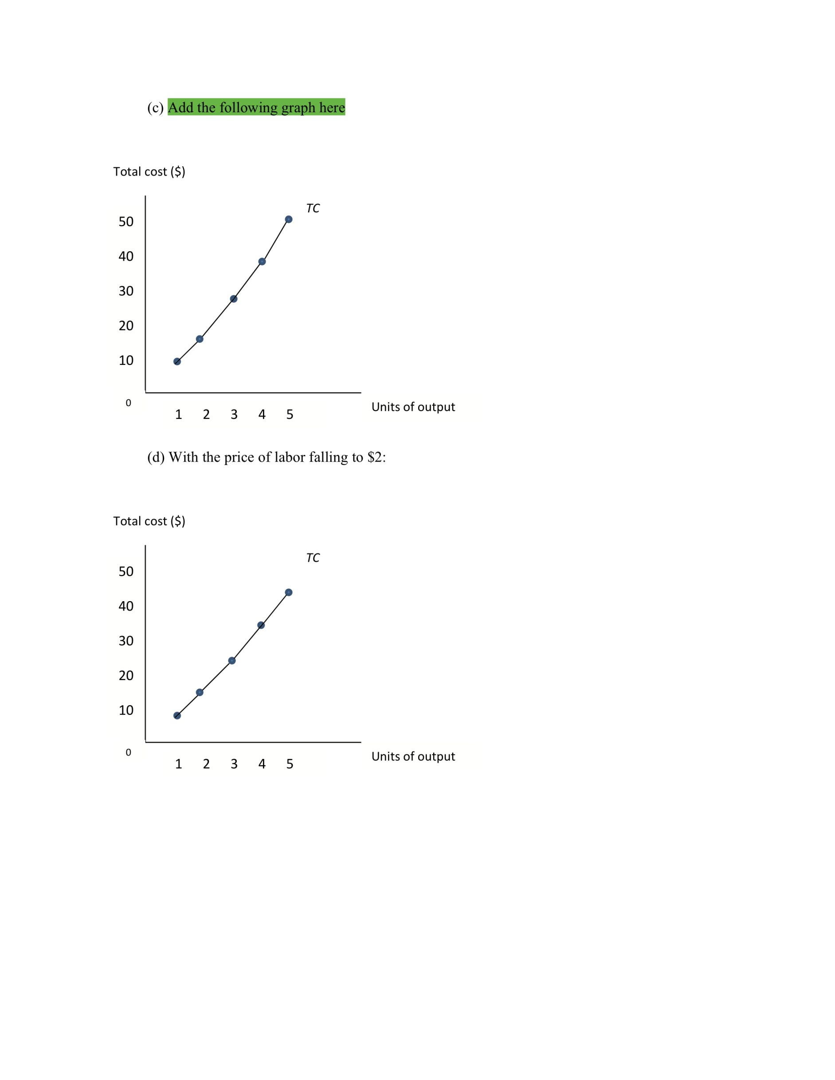

(d) With the price of labor falling to $2:



|  |  |  |  |  |  |
| --- | --- | --- | --- | --- | --- |
|  | Q = 1 | Q = 2 | Q = 3 | Q = 4 | Q = 5 |
| Tech a | $10 | $16 | $26 | $38 | $46 |
| tech b | $8 | $14 | $24 | $34 | $44 |

Technique B is still cheaper at all levels of output.

|  |  |  |
| --- | --- | --- |
| Q | L | K |
| 1 | 3 | 1 |
| 2 | 5 | 2 |
| 3 | 8 | 4 |
| 4 | 12 | 5 |
| 5 | 15 | 7 |

